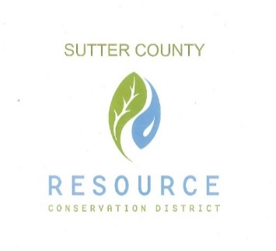

**SUTTER COUNTY RESOURCE CONSERVATION**

**DISTRICT BOARD MEETING AGENDA**

September 2, 2021 12:00 p.m.

Zoom link:   
 [https://us02web.zoom.us/j/85410778241?pwd=ZS9LSkkreTFieFhBdUIzdU9XOGI2QT09](https://www.google.com/url?q=https://us02web.zoom.us/j/85410778241?pwd%3DZS9LSkkreTFieFhBdUIzdU9XOGI2QT09&sa=D&source=calendar&usd=2&usg=AOvVaw3uAhVGBvR5UqERimRsTTu1)

CALL TO ORDER AND ROLL CALL

PUBLIC PARTICIPATION

Members of the public will be allowed to address the Board on items of interest that are the subject matter jurisdiction of the Board. Any member of the audience who may wish to bring a matter before the Board that is not on the agenda may do so at this time; however, State law provides no action may be taken on any item not appearing on the agenda. Comments shall be limited to three minutes.

CONSENT CALENDAR AND MONTHLY BILLS

The Consent Calendar groups together those items which are considered non-controversial or for which policy direction has been given to staff and that require only routine action by the Board. The Chair will advise the audience that the matters may be adopted in total by one motion; however, the Board may, at its option or upon request of a member of the public, consider any matter separately.

1. Approval of the minutes of the August meetings.
2. Payment of monthly bills.
3. Cash Flow Projection
4. Annual Budget

DISCUSSIONS AND ACTION ITEMS:

1. Review and re-approve long range/annual plan (2022 plan).
2. Technical Assistance Provider
3. Audit
4. Speak Off Contest Date
5. NACD Poster Contest

ONGOING DISTRICT BUSINES

1. Update on grants.
2. Update discussion on merger with Yuba RCD.
3. Update on office location.
4. Project Manager Update

OLD BUSINESS

NEW BUSINESS

CORRESPONDENCE

Next meeting will be held on October 7, 2021