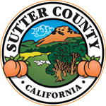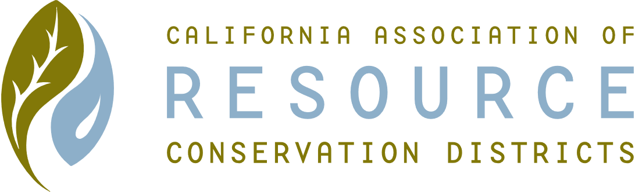**SUTTER COUNTY RESOURCE CONSERVATION**

**DISTRICT BOARD MEETING MINUTES**

**November 4, 2020**

**CALL TO ORDER**

Chair Jennifer Sanders called the meeting to order at 12:12 p.m.

**ROLL CALL**

**DIRECTORS PRESENT:** Jennifer Sanders, Kelli Evans, Mike Johnston and Jasdeep Bains

**DIRECTORS ABSENT:** None

**OTHERS PRESENT:** None

**APPROVAL OF MINUTES:**

Minutes of the October 2020 Board meeting Mike motioned, Jaz seconded. Unanimously approved.

**PUBLIC PARTICIPATION:**

None

**CONSENT CALENDAR AND MONTHLY BILLS**

Approval for payment of October bills and invoice from Colusa RCD for NAQI grant was motioned by Mike and seconded by Jaz. Approved by Jennifer, Mike and Jaz; Kelli abstained.

**ACTION ITEMS**

**ONGOING DISTRICT BUSINESS**

**Region Speak-Off**

Contestant Kirtan from Live Oak placed second in the district Speak-Off.

**Website**

Jennifer discussed the website and increasing exposure through the site.

**Grants**

Jennifer gave updates on the TA HUB and NAQI programs.

**Ethics Training/Brown Act/Form 700**

Discussed updating state RCD compliance.

**CARCD Conference Update**

Reminder that the conference starts on November 12-20 and the registration fee is $10.

**NEW DISTRICT BUSINESS**

**Restore California-Zero Footprint Outreach Grant**

Discussed possibilities of applying for this grant.

**Cal-Recycle Update**

Kelli provided Cal-Recycle update.

**CORRESPONDENCE**

Received a letter from Sara Letton, California RCD Grant Manager.

Received a letter from Nicole Cartwright, California RCD.

**ADJOURN**

Meeting was adjourned at 1:38 p.m.

Next regular meeting is scheduled for December 4, 2020.