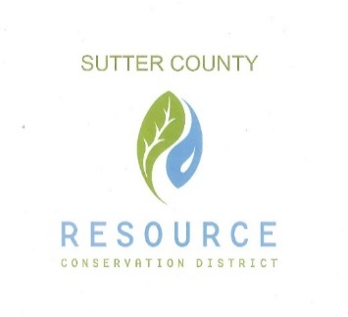

**SUTTER COUNTY RESOURCE CONSERVATION**

**DISTRICT SPECIAL BOARD MEETING AGENDA**

June 3, 2021 12:00 p.m.

Zoom link:   
 <https://us02web.zoom.us/j/86837407748>

COVID-19 PROTOCOLS IN PLACE: Please wear a mask when inside the Ag Office Building.

CALL TO ORDER AND ROLL CALL

ACCEPTANCE OF AGENDA

Members of the Board and/or staff may request additions, deletions, and/or changes in the agenda.

PUBLIC PARTICIPATION

Members of the public will be allowed to address the Board on items of interest that are the subject matter jurisdiction of the Board. Any member of the audience who may wish to bring a matter before the Board that is not on the agenda may do so at this time; however, State law provides no action may be taken on any item not appearing on the agenda. Comments shall be limited to three minutes.

CONSENT CALENDAR AND MONTHLY BILLS

The Consent Calendar groups together those items which are considered non-controversial or for which policy direction has been given to staff and that require only routine action by the Board. The Chair will advise the audience that the matters may be adopted in total by one motion; however, the Board may, at its option or upon request of a member of the public, consider any matter separately.

1. Approval of the minutes of the April 1, 2021 and April 8, 2021 and May 6, 2021 meetings.
2. Payment of monthly bills.
3. Cash Flow Projection

DISCUSSIONS AND ACTION ITEMS:

1. Ongoing Projects
2. Nature Bowl Update
3. Resource Day
4. Cal- recycle
5. NAQI
6. Specialty Crop Hub
7. Colusa-Yuba-Sutter Monarch Grant Collaboration
8. Parkway Project
9. New projects
10. Update discussion on merger with Yuba RCD
11. Discuss new hire

MISC. STAFF AND DIRECTOR REPORTS:

AJOURNMENT.

**Next meeting will be held on July 1, 2021 at 12:00 PM**