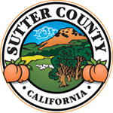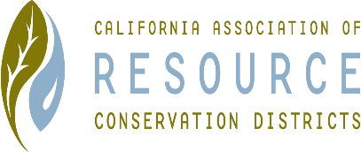**SUTTER COUNTY RESOURCE CONSERVATION**

**DISTRICT BOARD MEETING MINUTES**

**September 2, 2021**

**CALL TO ORDER**

Kelli Evans called the meeting to order at 12:25 p.m.

**ROLL CALL**

**DIRECTORS PRESENT:** Kelli Evans, Jennifer Sanders and Jasdeep Bains

**DIRECTORS ABSENT:** Mike Johnston

**ADDITIONS:** N/A

**APPROVAL OF MINUTES:**

Minutes of the August 2021 Board meetings Jennifer motioned, Jas seconded. Unanimously approved.

**PUBLIC PARTICIPATION:**

N/A.

**CONSENT CALENDAR AND MONTHLY BILLS**

Approval for August meetings.  Jennifer motioned; Jas seconded. Approval of monthly bills, insurance, Invoice for Project Managers time, and reimbursements to Kelli and the Project Manager. Unanimously approved.

Cash flow projection: only down $300 from the beginning of the year.

**VOTE**

Technical Assistance Provider pay. Jennifer motioned; Jas Seconds. Unanimously approved.

Participate in the NACD Poster Contest. Jennifer motioned; Jas Seconds. Unanimously approved.

Speak Off- Jas will set a date and time for the competition and reach out to the High schools. Jennifer motioned; Jas Seconds. Unanimously approved.

**ACTION ITEMS**

N/A

**ONGOING DISTRICT BUSINESS**

**NEW DISTRICT BUSINESS**

N/A

**CORRESPONDENCE**

None received.

**ADJOURN**

Meeting was adjourned at 12:35 p.m.

Next regular meeting is scheduled for October 7, 2021.