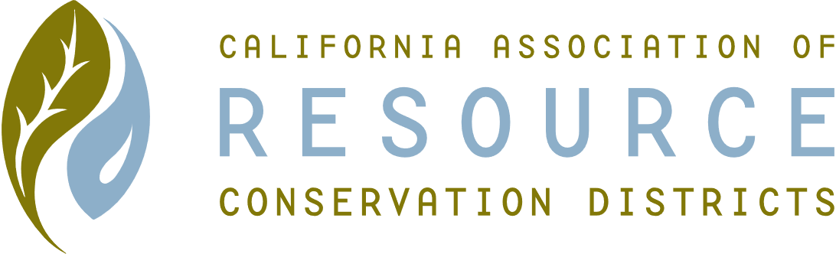**SUTTER COUNTY RESOURCE CONSERVATION**

**DISTRICT BOARD MEETING MINUTES**

**Thursday October 2, 2020**

**CALL TO ORDER**

Chair Jennifer Sanders called the meeting to order at 12:30 p.m.

**ROLL CALL**

**DIRECTORS PRESENT:** Jennifer Sanders, Kelli Evans, Mike Johnston

**DIRECTORS ABSENT:** Ricardo Neto

**OTHERS PRESENT:** None

**APPROVAL OF MINUTES:**

Minutes of the September 3, 2020 Board meeting Kelli motioned, Mike seconded. Unanimously approved.

**PUBLIC PARTICIPATION:**

None

**CONSENT CALENDAR AND MONTHLY BILLS**

State membership due in the amount of $150. Ricardo to make check out. Mike motioned, Kelli seconded, unanimously approved.

**ACTION ITEMS**

**ONGOING DISTRICT BUSINESS**

Speak Off – Freshman and 2 seniors will be participating via Zoom on October 8th at 2:00 p.m. Will have 3 judges and 1 timekeeper.

**WEBSITE**

Jennifer is almost done with the website. URL still to be sorted out. Domain needs to be reclaimed. Jennifer presented the website and discussion about content was held. Terms of officers were also discussed. Compliance Review to be added to the agenda under Ongoing Business. Brown Act and Ethics training specifically to be placed on the November agenda for compliance.

**GRANTS**

Biding processes were discussed.

Cal Recycle tie in to possible donation requests was discussed, as well as other grant possibilities available the next few months.

Mike reported that Sutter County did award the RCD $5,000 as requested. Delta Conservancy grant does not have a nexus to RCD and therefore we are not eligible. The grant writing company who will be researching grants that will apply to the RCD. Other possible grants were discussed. Kelli motioned for payment of $2,600 to the grant company; Mike seconded. Unanimously approved.

Kelli reported that the NAQI contract period has ended. Final invoice coming; and to be placed on November agenda. Colusa can then be closed out.

Part-time District Manager position discussed. Job description to be placed on website, and out on local newspapers. Will cut off on the 30th of the month. Will also need to purchase laptop and cell phone for employee. Mike may possibly have equipment.

CARCD Capacity Building grant was missed as RCD does not have a long-range plan. Draft to be created and discussed at the November meeting. HUB Grant also discussed.

**NEW DISTRICT BUSINESS**

None

**CORRESPONDENCE**

None

**ADJOURN**

Meeting was adjourned at 2:11 p.m.

Next regular meeting is scheduled for November 5, 2020.