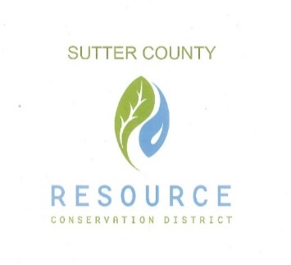

BOARD OF DIRECTORS

& STAFF

PRESIDENT

Jennifer Wallace Sanders

VICE PRESIDENT

Kelli Evans

SECRETARY

Mike Johnston

TREASURER

Vacant

DIRECTOR

Jasdeep Bains

DISTRICT MANAGER

Vacant

‘

**SUTTER COUNTY RESOURCE CONSERVATION**

**DISTRICT BOARD SPECIAL MEETING AGENDA**

This meeting will be held via Zoom Conferencing Service

<https://zoom.us/j/93726486254>

Meeting ID: 937 2648 6254

February 9, 2021 12:00 p.m.

CALL TO ORDER AND ROLL CALL

PUBLIC PARTICIPATION

Members of the public will be allowed to address the Board on items of interest that are the subject matter jurisdiction of the Board. Any member of the audience who may wish to bring a matter before the Board that is not on the agenda may do so at this time; however, State law provides no action may be taken on any item not appearing on the Agenda. Comments shall be limited to three minutes.

ONGOING BUSINESS

Discuss and Vote on California Special District Association (CSDA) request for letter of support of pending Federal legislation.

CORRESPONDENCE

ADJOURNMENT