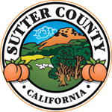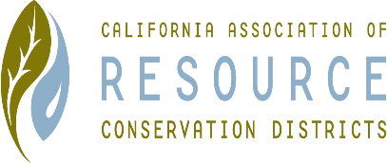**SUTTER COUNTY RESOURCE CONSERVATION**

**DISTRICT BOARD SPECIAL MEETING MINUTES**

**December 03, 2021**

**CALL TO ORDER**

Jennifer Sanders called the meeting to order at 3:16 p.m.

**ROLL CALL**

**DIRECTORS PRESENT:** Kelli Evans, Jasdeep Bains, and Jennifer Sanders

**DIRECTORS ABSENT:** Mike Johnston and Tirath Johal

**ADDITIONS:** N/A

**VOTE**

Discuss and Vote on custom flag, new logo, and table cloths for the event. Kelli motioned; Jas seconded.

Approval of the creation of Personnel committee (Kelli and Jennifer) to discuss all pay, position, and personal matters. Jas motioned; Kelli seconded.

**CORRESPONDENCE**

None received.

**ADJOURN**

Meeting was adjourned at 3:24 p.m.

Next regular meeting is scheduled for January 06, 2022.