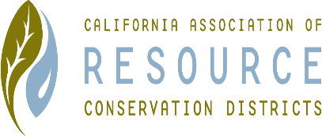**SUTTER COUNTY RESOURCE CONSERVATION**

**DISTRICT BOARD SPECIAL MEETING MINUTES**

**August 24, 2021**

**CALL TO ORDER**

Kelli Evans called the meeting to order at 1:52 p.m.

**ROLL CALL**

**DIRECTORS PRESENT:** Kelli Evans, Mike Johnston and Jasdeep Bains

**DIRECTORS ABSENT:** Jennifer Sanders

**ADDITIONS:** N/A

**VOTE**

Discuss and Vote on Cal-recycle sites and the Board agrees that if funded projects must be done on time. Mike motions Resolution 21-1, Jas seconds. Unanimously approved.

Discuss and Vote on New Member Tirath S. Johal as the fifth and final member of the Sutter County Resource Conservation District Board. Mike motions Resolution 21-2, Jas seconds. Unanimously approved.

**CORRESPONDENCE**

None received.

**ADJOURN**

Meeting was adjourned at 1:56 p.m.

Next regular meeting is scheduled for September 2, 2021.