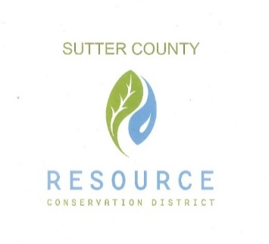

BOARD OF DIRECTORS

& STAFF

PRESIDENT

Jennifer Wallace Sanders

VICE PRESIDENT

Kelli Evans

SECRETARY

Mike Johnston

TREASURER

Ricardo Neto

DIRECTOR

Vacant

DISTRICT MANAGER

Vacant

‘

**SUTTER COUNTY RESOURCE CONSERVATION**

**DISTRICT BOARD MEETING AGENDA**

9792 Live Oak Blvd, Suite E

Live Oak, CA 95953

September 3, 2020 12:00 p.m.

CALL TO ORDER AND ROLL CALL

PUBLIC PARTICIPATION

Members of the public will be allowed to address the Board on items of interest that are the subject matter jurisdiction of the Board. Any member of the audience who may wish to bring a matter before the Board that is not on the agenda may do so at this time; however, State law provides no action may be taken on any item not appearing on the Agenda. Comments shall be limited to three minutes.

CONSENT CALENDAR AND MONTHLY BILLS

The Consent Calendar groups together those items which are considered non-controversial or for which policy direction has been given to staff and that require only routine action by the Board. The Chair will advise the audience that the matters may be adopted in total by one motion; however, the Board may, at its option or upon request of a member of the public, consider any matter separately.

1. Approval of the minutes of the August 6, 2020 meeting.
2. Payment of monthly bills for August.

ONGOING DISTRICT BUSINESS

1. Grant review
2. Update on Feather River Parkway Project
3. Cal Recycle

NEW BUSINESS

1. Farm and Ranch Solid Waste Cleanup and Abatement Grant
2. Resolution for 70 cycle sites

APPOINTED COMMITTEE REPORTS

CORRESPONDENCE

ADJOURNMENT