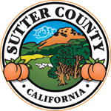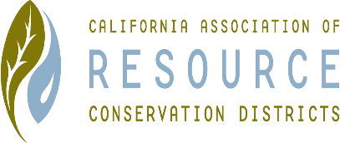**SUTTER COUNTY RESOURCE CONSERVATION**

**DISTRICT BOARD MEETING MINUTES**

**Thursday June 4, 2020**

**CALL TO ORDER**

Chair Jennifer Sanders called the meeting to order at 12:05 p.m.

**ROLL CALL**

**DIRECTORS PRESENT:** Jennifer Sanders, Kelli Evans, Mike Johnston

**DIRECTORS ABSENT:** Ricardo Neto

**OTHERS PRESENT:** None

**APPROVAL OF MINUTES:**

Minutes of the May 2020 Board meeting unanimously approved. Minutes from the March 2020 meeting will be obtained from Pam Clifton and approved at a future meeting.

**PUBLIC PARTICIPATION:**

None

**CONSENT CALENDAR AND MONTHLY BILLS**

Consent calendar and payment of January bills unanimously approved.

**ACTION ITEMS**

Discussion of the Region Speak-Off contest was held. Motion to spend $100 for prize money made by Jennifer, seconded by Kelli; unanimously approved.

**ONGOING DISTRICT BUSINESS**

1. The NCRS contract was discussed. $25,000 of the remaining balance requires the hiring of a staff member to fulfill the requirements of the contract which expires October. Jennifer motioned to hire a part time employee to fulfill the NCRS agreement. Mike seconded, unanimously approved. The job description will be written by Jennifer.
2. Treasurer and Secretary elections were held. Mike nominated Ricardo for Treasurer; unanimously approved. Jennifer nominated Mike for Secretary, Kelli seconded; unanimously approved.
3. Mail box update. $106 was spent to purchase a PO Box located at Plumas Street. Good until July 2021.
4. Budget approval. Discussion was held regarding the approval of the fiscal year 2020/21. Mike will request usual $5,000 contribution from Sutter County. Jennifer and Kelli will prepare the letter to accompany the request. Mike motioned, Kelli seconded; unanimously approved.
5. Moving of Office Furniture. Most items have been moved or placed in storage. The generator is still for sale; and is approximately worth $150 as it needs repairs. Jennifer motioned Kelli seconded to sell for $150; unanimously approved.
6. Website – Jennifer was appointed to take over the website which will allow us to post the agendas and minutes.
7. Speech-Off Contest – Ricardo will lead the contest.
8. Cal-Recycle Grants – Growers are being lined out currently; still in the current round.
9. New Board Members –still have 1 more board position available; ideally would like 2.
10. Grants – Yolo County is leading a grant-writing effort for the Sacramento Valley Regional Fire/Wildfire Prevention to encourage land owners to create their own wildfire prevention association. Ultimate goal to have private association to take responsibility for prescribed burning. A part time grant writing staff member’s effort could potentially recover $400 for the district. Capacity Building grant, which requires 25% match, is due in 20 days. Kelli is following up on submission. Other grants were discussed which we can work on as our capacity builds.

**NEW DISTRICT BUSINESS**

None

**APPOINTED COMMITTEE REPORTS**

None

**CORRESPONDENCE**

None

**ADJOURN**

Meeting was adjourned at 1:21 p.m.

Next meeting scheduled for July 2, 2020