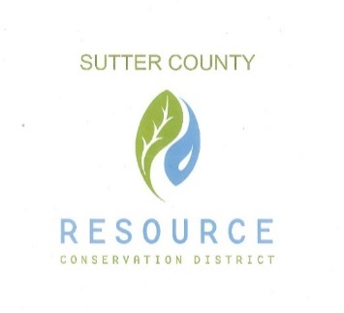

**SUTTER COUNTY RESOURCE CONSERVATION**

**DISTRICT SPECIAL BOARD MEETING AGENDA**

August 24, 2021 1:45 p.m.

Zoom link:   
 <https://www.google.com/url?q=https://us02web.zoom.us/j/87613007550?pwd%3DSU9TR2lBODRkdmUybVl1Mk5tUHRNQT09&sa=D&source=calendar&usd=2&usg=AOvVaw36uhhYWaxKu_Y8g4BKHvqU>

CALL TO ORDER AND ROLL CALL

PUBLIC PARTICIPATION

Members of the public will be allowed to address the Board on items of interest that are the subject matter jurisdiction of the Board. Any member of the audience who may wish to bring a matter before the Board that is not on the agenda may do so at this time; however, State law provides no action may be taken on any item not appearing on the agenda. Comments shall be limited to three minutes.

ONGOING BUSINESS

Discuss and Vote on resolution of The Board of Directors of the Sutter County Resource Conservation District and approving the application for the Farm and Ranch Solid Waste Cleanup and Abatement Grant for their current projects.

Discuss and Vote on resolution of The Board of Directors of the Sutter County resource Conservation District to appoint Tirath Singh Johal as a Director.

CORRESPONDENCE

Next meeting will be held on September 2, 2021