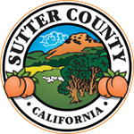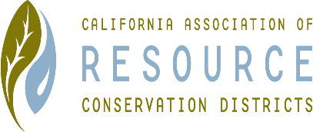**SUTTER COUNTY RESOURCE CONSERVATION**

**DISTRICT BOARD MEETING MINUTES**

**Thursday September 3, 2020**

**CALL TO ORDER**

Chair Jennifer Sanders called the meeting to order at 12:01 p.m.

**ROLL CALL**

**DIRECTORS PRESENT:** Kelli Evans, Mike Johnston, Ricardo Neto

**DIRECTORS ABSENT:** Jennifer Sanders

**OTHERS PRESENT:** None

**APPROVAL OF MINUTES:**

Minutes of the August 8, 2020 Board meeting Mike motioned, Ricardo seconded. Unanimously approved.

**PUBLIC PARTICIPATION:**

None

**CONSENT CALENDAR AND MONTHLY BILLS**

No bills for August, and no approvals.

**ACTION ITEMS**

**ONGOING DISTRICT BUSINESS**

Speak Off – FFA said after October 2nd, and after 1 p.m. is preferred. Date and time of October 8th at 2:00 p.m. was set for the virtual Speak Off. Ricardo will send the information to Justine. Last year there were 5 participants, all from Live Oak.

**WEBSITE**

Jennifer attended training on the website, and has paid for access to the old website. She will request reimbursement at the October meeting.

**GRANTS**

Mike contacted the grant writer and will be they will be conducting a Zoom meeting, and Mike will invite the rest of the board members. Mike reported he has sent the $5,000 contribution request to the Sutter County Board of Supervisors.

Kelli reported that the Cal Recycle project plan submitted. Total is $300,000 between Yuba and Sutter. On the 15th, the report will be out. Further discussion about the project was held. Motion to apply again for Cal Recycle was made by Ricardo, seconded by Mike; unanimously approved.

Kelli reported that the NAQI agreement was extended to 2021, which allows for RCD to hire staff. Jennifer would like to have the grant writing experience added to the job description for staff member.

**NEW DISTRICT BUSINESS**

Received the Hub grant for healthy soils technical assistance in the amount of $35,000; the only RCD to be awarded in the State.

**CORRESPONDENCE**

None

**ADJOURN**

Meeting was adjourned at 12:45 p.m.

Next regular meeting is scheduled for October 1, 2020.