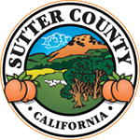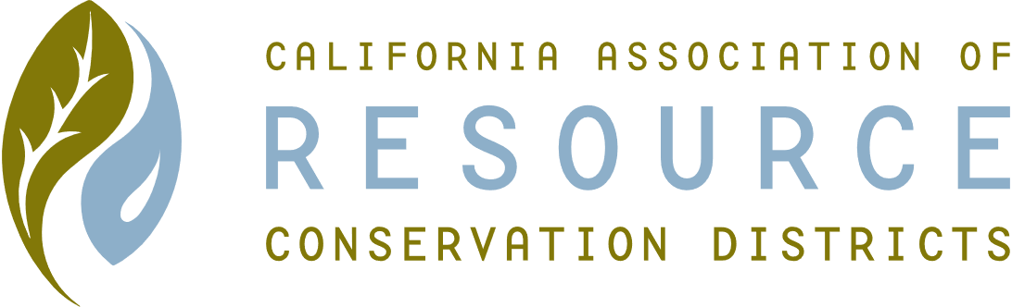**SUTTER COUNTY RESOURCE CONSERVATION**

**DISTRICT BOARD MEETING MINUTES**

**April 8, 2021**

**CALL TO ORDER**

Jennifer Sanders called the meeting to order at 12:14 p.m.

**ROLL CALL**

**DIRECTORS PRESENT:** Jennifer Sanders, Kelli Evans, Jasdeep Bains

**DIRECTORS ABSENT:**  Mike Johnston

**PUBLIC PARTICIPATION:** None.

**ACTION ITEMS:**

1. Discussion videographer/translator
   1. Hiring Jorge Maldonado
      1. No Second Choice
   2. Hiring Jaspreet Singh
      1. Backup - Raminder Bains
   3. Hiring Liliana Pinedo – no in person translating, but can translate material and content for now, can hire another individual for actual workshops. Can possibly ask Victor.
      1. Back up – Luis Moreno
2. Approve videographer/translator
   1. Motion to approve – by Kelli Evans
      1. Punjabi: Jaspreet Singh, Raminder Bains
      2. Spanish: Liliana Pinedo, Luis Moreno
      3. Videographer: Jorge Maldonado
   2. All In Favor, motion passes

Meeting was adjourned at 12:21 p.m.