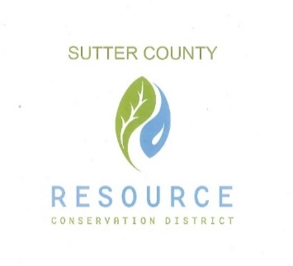

BOARD OF DIRECTORS

& STAFF

PRESIDENT

Jennifer Wallace Sanders

VICE PRESIDENT

Kelli Evans

SECRETARY

Mike Johnston

TREASURER

Ricardo Neto

DIRECTOR

Vacant

DISTRICT MANAGER

Vacant

‘

**AGENDA**

Workshop

July 20, 2020 12:00 p.m.

Feather River Parkway Project